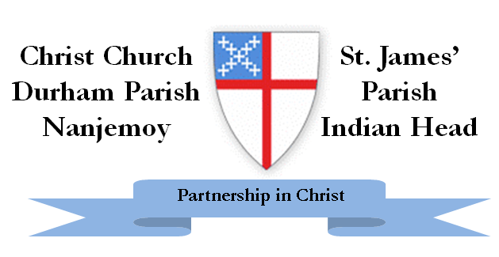
On Saturday, September 27, 2014, the Vestry of Christ Church, Durham Parish, the Vestry of St. James’, Indian Head, Rev. Molly McCarty, and Rev. Denise Cabana met in the Parish Hall at St. James’. The purpose of the meeting was to work together to create a statement of shared ministry that would accurately portray our collaborative efforts.
The meeting opened with the Holy Eucharist written by the Wild Goose Worship Group on the Holy Isle of Iona. Following the service small groups were formed with representation from both Vestries to discuss what our shared ministry will look like, and what the shared statement should look like. The group, as a whole, worked together to craft the statement and determine several areas of work that would demonstrate our shared ministry and provide an environment where the process can be measured. At the conclusion of the meeting a statement reflecting the beliefs and commitments of all present was written, and three goals in shared ministry were established.
The statement is:
Through our Partnership in Christ we will provide a vibrant witness to God’s generous and loving presence. We commit to sharing our resources while maintaining our unique identities. Together we will embrace and enhance new and established ministries.

The following three goals were established:
- Communication by providing shared information in weekly Bulletins, and Announcements. To work together to share website and Facebook information. Coordinating event schedules, sharing calendars, and emailing notifications and reminders are part of this effort.

- Worship together in a number of shared services through the year. The Holy Week collaboration of last year concluding with the Easter Vigil was very successful and spiritually fulfilling. Holy Week services will be done in 2015 with services shared or alternating between the two Parishes. This would include enjoying music by our joined choirs for the service.
- Fun activities and events to enjoy our common community. Perhaps shared picnics, Karaoke gatherings, and more. It could be joining St. James’ at a table distributing information about our Parishes at the “Taste of Indian Head”, or St. James’ joining the Hunger walk with Durham at Serenity Farm. These events would also provide activities for youth.
Thank you for reading this message on the collaborative, or better stated, shared ministry between Durham and St. James’. If you have questions, please contact a Vestry member. More information will become available as the process continues. Both Parishes intend to make this process as transparent as possible.

