
March 2016

Rector’s Ramblings
Looking forward to Holy Week

Greetings Church,

Every Sunday is a feast of Christ’s resurrection. The church is our human response to Christ’s life and gospel and is the
means for forging our communal life in Jesus’ name. Our church life, as demanding and wonderful as it can be, is the
crucible of faith, hope and love which instructs and strengthens us to love God with our whole heart, our whole
mind and our souls and to love our neighbors as ourselves. The Collect on page 98 of The Book of Common Prayer
describes this hope for Christian community in the church very well. “O God, you make us glad with the weekly
remembrance of the glorious resurrection of your Son our Lord: Give us this day such blessings through our worship of
you, that the week to come may be spent in your favor.”

If we celebrate the Resurrection of Christ weekly, why, then is Holy Week, which is our reliving of Jesus’ last week of life among us hold a central fact of our life together as Christians? Holy week, which is eight days long, is an extended meditation on the facts of the last week of Jesus’ life. These eight days takes us a journey from the Victory of Palm Sunday to the passion on the cross and to the final victory of Easter. We walk the via Doloroso with Jesus. We not only read, pray, study, we actually, begin to live the sacrament of his last days with us . We come to know and understand why we are Christians. God has joined us in our suffering and walks with us to victory. We experience that learning on the Via Doloroso and on Easter. In and through Holy Week, we come to know first hand that God has not abandoned us because we live through Jesus’ life. We emerge from Holy Week renewed and fortified with a deeper acceptance of the truth that Christ is very much with us.

The events of this week draw us into a different space and time where we are engaged, body, mind and soul in the
Kingship, the Passion, and the joy of resurrection. Palm Sunday, draws us into Jerusalem where we stand with our
psalms, singing our alleluias. We are then drawn towards the passion of Jesus through the contemplative service of
Tenebrae, the service of shadows where we anticipate Christ’s suffering. We gather in respite for the Last Supper,
Maundy Thursday, where we wash the feet of our neighbors and share an Agape meal before turning our faces and
attention towards Golgotha. On Good Friday we remember the crucifixion of Christ. We walk the Via Doloroso with
Christ through the Noon service of the Stations of the Cross and our evening Good Friday service. Good Friday’s Book of
Common Prayer collect expresses it this way, “behold this your family, for whom our Lord Jesus Christ was willing to be
betrayed”. Saturday is the day of the tomb and there are prayers and readings which can be read and said at home.
We approach Saturday evening, not only with our mourning but our anticipation and knowledge of what lies beyond is the Victory of the Resurrection. The Saturday Easter Vigil starts with a lighting of the Paschal candle with fire in the back of the church. It proceeds through our history with God through the stories of the Old covenant to the gift of the new
covenant. We renew our baptismal vows and the church bursts into joyous acclamations that Christ is Risen!!!! It is the
singular proclamation of our faith. With Easter Sunday’s alleluias , we rejoice on the most important day in the
Christian life.

Please join your community and invite friends to be with us for as many services as possible. Enter into your story, Jesus’ story, this Holy Week.
God Bless You!

Nan+


Message from your Outgoing Senior Warden
I am honored to have had the opportunity to serve as senior warden. I appreciate all the support and encouragement I received. During our time of transition, the congregation of St. James' was a blessing to our church. We truly embody having a servant's heart and uniting for the glory of God.
Moving forward, it is my prayer that we embrace more opportunities to impact the community and our parish at large. I am confident that we will find a priest who will be fortunate and blessed to accept a call to St. James'. I assure you we will not settle for someone who is not the right fit for our church. Please keep St. James' in your prayers and our future rector.
Faithfully,
Linda


By Jr. Warden
Words to ponder as we continue our journey through Lent, Holy Week, and Easter:
James 1:2-4
Consider it all joy, my brothers, when you meet with various trials, knowing as you do that this tested quality of your faith produces endurance. But let endurance complete its work, so that you may be complete and sound in all respects, not lacking in anything.
In Christ Love,
Thomas Gordon

ECW

Although it’s only March, the ECW has had a busy year.

We have had two fish fries and another one is scheduled for Friday, March 18.

We are also looking forward to having a spring dinner on April 23. It will be corned beef, ham, cabbage, parsley potatoes, green beans, carrot salad, and of course dessert.

Please join us in making plans for our upcoming events.
We welcome all of the St. James’ women when we meet on the second Sundays in each month.

In Christ’s love and peace,
Sheila Gray, ECW President

The Search Committee

The search committee is compiling the data from our survey to utilize when writing our parish profile. Once everyone has turned in their survey, I will complete our report and share the data with the congregation. We are making progress and are ahead of schedule. Please keep the search committee in your prayers.
In His Service,
Linda



March 22 | 7:00 PM | Evening Prayer
March 23 | 7:00 PM | Tenebrae
March 24 | 7:00 PM | Maundy Thursday  (Foot Washing and  Agape Meal)
March 25 | 12:00 PM  7:00 PM | Stations of the Cross  Good Friday Service
March 26 | 7:00 PM | Easter Vigil
March 27 | 8:00 AM  9:00 AM  9:30 AM  10:30 AM | Easter  Easter – Children’s Service  Easter Egg Hunt  followed by Easter Celebration  in the Parish Hall  Easter Service with Music

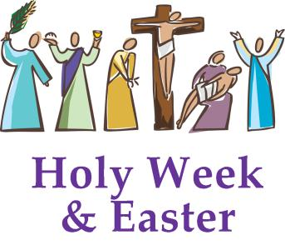





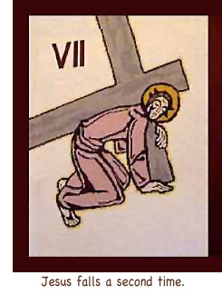





Free Community Spaghetti Dinner

Donations of $251 were received at the free community spaghetti dinner held on February 1st (postponed from January 25th due to snow).
The next spaghetti dinner will be held on Monday, March 28th. We are in need of sauce, Italian dressing, and as always, desserts. Sign-up sheet to help is on the bulletin board.

 Parish Hall Rental
We are continuing to promote the rental of the parish hall as it is a great source of church income. The rates are as follows:
Parishioners of St. James’
Asked to make a donation of $100.00

Non-parishioners
$350.00/first 4 hours - Limited use of the kitchen
$50.00 each additional hour

$400.00/first 4 hours - Full use of the kitchen
$50.00 each additional hour

A signed contract is included for the use of the hall.
If you know of anyone that needs to use a hall for a wedding reception, dinner, birthday party, etc., or if you have any questions please have them contact Karen Burroughs.

Spring Tea
May 7, 2016
12:00 PM – 2:30 PM
Pavilion in Indian Head, Maryland

Theme: “You are our biggest Fan”

Join us for a celebration of Spring!

Tickets: $18.00 per person

Bring your Favorite Teacup
and
Wear your Beautiful Spring Hat

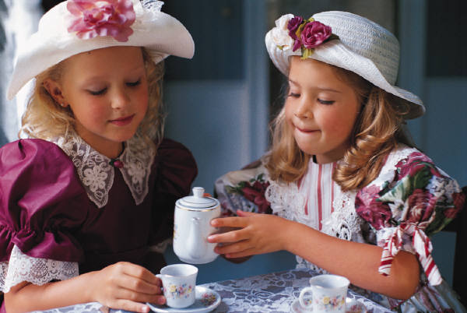






Hat Contest

Teacup Contest



Door Prizes




Dear Friends: Since God so loved us, we also ought to love one another. 1 John 4.11
FELLOWSHIP
I’m still waiting for new or old ideas for getting together. Of course, that means that “you” have to help.
I think an afternoon of games would be fun. What do you think? Would you come? What games would you like to learn? I love to play Hand and Foot Canasta and would like to show you how to play. Let me know if you are interested.
Don’t have a date yet, but Karaoke should be coming up pretty soon.
Summer is just around
the
corner.
Love in Christ,
Adah

Events will all be posted on the bulletin board for sin-up. Keep an eye out for the things you want to do, better yet do them all!
God Bless You All,
Adah

 On Beads of Prayer Ministry
We sent almost 200 sets of beads that were made by members of St. James to Chaplain Patrick Lothian in Columbia, SC last month. Beading is now on hold until after Easter.
Have a GREAT day!
Martha



Finances

Brief Financial Update

Thank you all sooooo much for meeting the challenges that were presented to you at the annual meeting. We had a generous parishioner offer up a challenge as follows “I will match any additional donation amount up to $3,000”! As a result of that challenge, 2 folks have stepped up to the challenge; 1 gave $3,000 and the other $500! Wow! That’s wonderful, isn’t it? I have had a few people say something about meeting the additional challenge of increasing their pledge by $5 a week and that helps a lot!

And for the first time in 3 years, we were able to have our Pancake Supper (although it did threaten to snow). We made a profit of $957 for our efforts. Combining all that with an extremely mild Winter, puts us comfortably ahead for this time of year! Keep it up! Remember we want to show a solid financial foundation on which to build a future with a full time Rector!!

If at any time during the year you want to know where you are in relationship to your pledged amount, feel free to ask me.

Tom





NETS
(Neighbors Eager To Serve)

NETS is providing 40 Easter food baskets to the needy this year. Members within out church are providing 13 Easter Baskets for 13 lucky children. It is such a blessing to be able to make Easter a happy and thankful time for those who are less fortunate than ourselves.
Thank you for helping to make this happen.
God Bless You,
Barbara Prasser (B2).

Grace
God 
Reach 
Action 
Compassion 
Euchurist 

Please let us know if someone is in need of a visitation, card, or a phone call.

God’s Blessings,
Adah, Linda, Brenda, Mary Ann



ST. JAMES’ 2015/2016 SUNDAY SCHOOL EVENTS

2016
We had a great time making pretzels on Feb. 28th.

Hope you enjoyed eating them.

March 20   | Palm Sunday  Children Read the Passion at the 9:15 a.m. Children’s Service  All the parts have been handed out and the children should practice them and bring their papers with them on Sunday.
March 27     | Easter Sunday Don’t forget to bring 3 hardboiled eggs.  Easter Egg Hunt after a 9:05 a.m. service  Bring a Friend to Church
  April 10 | Sunday School will go Bowling after church.  Please let Jack Rogers know as soon as possible if you are going bowling with us or not,
  May 22 | Sundae-Making Sunday after the 9:15 a.m. service  Bring a Friend to Church.
June 5   | Children’s Service at 10:30 a.m.; Kids will participate.  Sunday School Awards will be presented during Coffee Hour.


I was born and raised around here and if I told you what I did for a living, it would give it away. I have 4 children and you know them all!
(The answer to the last challenge is Susie Strauss Martin)

Guess who this st. james’ parishioner is!

Our mission statement:
We generously share our blessings in the name of Christ with the hope of showing God’s love to others.

